**VPC TASK – 01:**

**1.Create VPC with 2 private and 2 public subnets:**

Open VPC Console → Subnets → Create Subnet

Select the VPC ID: my-vpc-01

Enter a Subnet Name: Public-subnet-01

Choose Availability Zone no preference

Enter IPv4 CIDR Block: 172.168.0.0/26

Total 64 Ips

**2.Enable DNS Hostname in VPC:**

Open AWS Management Console

In the top search bar, type **VPC**.

Click on **VPC** service.

My-VPC-01

Click the Details tab.

A panel opens at the bottom.

On the right side, click Edit VPC settings.

Turn ON both checkboxes:

**DNS resolution**

**DNS hostnames**

Click **Save changes**

**3.Enable Auto Assign Public IP in 2 public subnets:**

Go to **AWS Console**

Open **VPC** service

Select Public-subnet-01

From the subnet list, click Public-subnet-01

Click **Subnet actions** dropdown

Select **Edit subnet settings**

Enable auto-assign public IPv4 address

**4.Add 2 private subnets in private route table:**

Open Route Tables

Go to AWS Console

Open VPC service

click Route Tables

Open Subnet Associations

Click the Subnet associations tab

Then click Edit subnet associations

Select Both Private Subnets

**5.Add 2 public subnets in public route table:**

Open Route Tables

Go to AWS Console

Open VPC service

Open Subnet Associations

In the bottom details panel:

Click Subnet associations tab

Then click Edit subnet associations

Select Both Public Subnets 1 and 2

Public-subnet-01

Public-subnet-02

Click **Save associations**

**6.Public route table will have the routes to internet and local:**

Open Internet Gateways

Go to AWS Console

Open VPC service

Click Create internet gateway

Name it: MYIGW

After creating → Select it

Click Actions → Attach to VPC

Choose your VPC (my-vpc-01)

VPC → Route Tables → public-rt → Routes → Edit routes

|  |  |
| --- | --- |
|  |  |

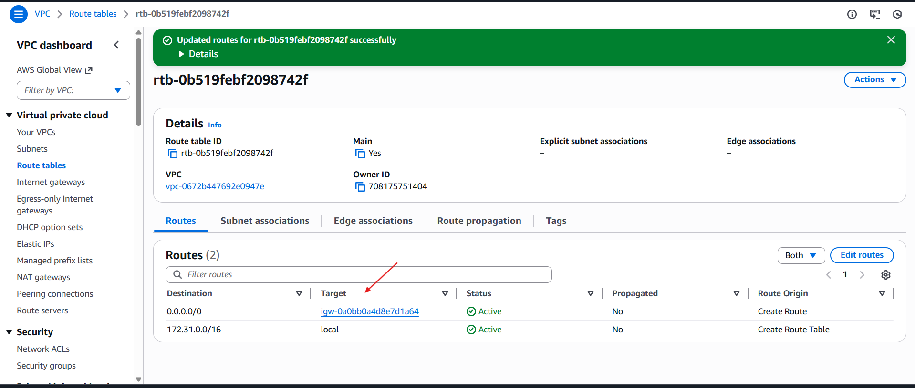

**7) Create EC2 in public subnet with t2.micro and install PHP:**

Search for EC2

Launch EC2 Instance

Select the Amazon Linux AMI

Under Network Settings, choose your VPC and select the public subnet.

In the Security Group, add the following inbound rules:

SSH (port 22) • HTTP (port 80)

sudo yum update -y

sudo yum install httpd -y

systemctl status httpd

sudo systemctl start httpd

sudo yum install -y php php-cli php-mysqlnd

